PYSPARK

S.R.TAANUSRI

27.12.2023

1.GETTING CURRENT DATE

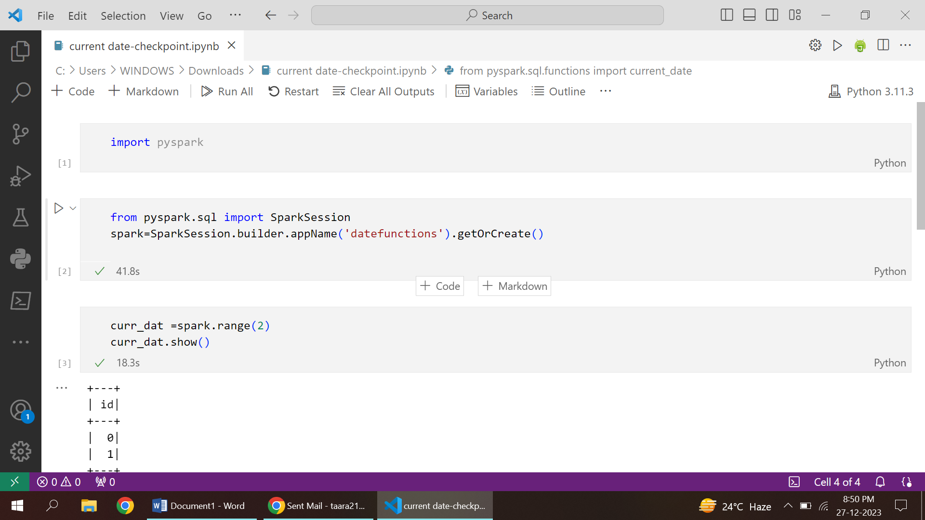

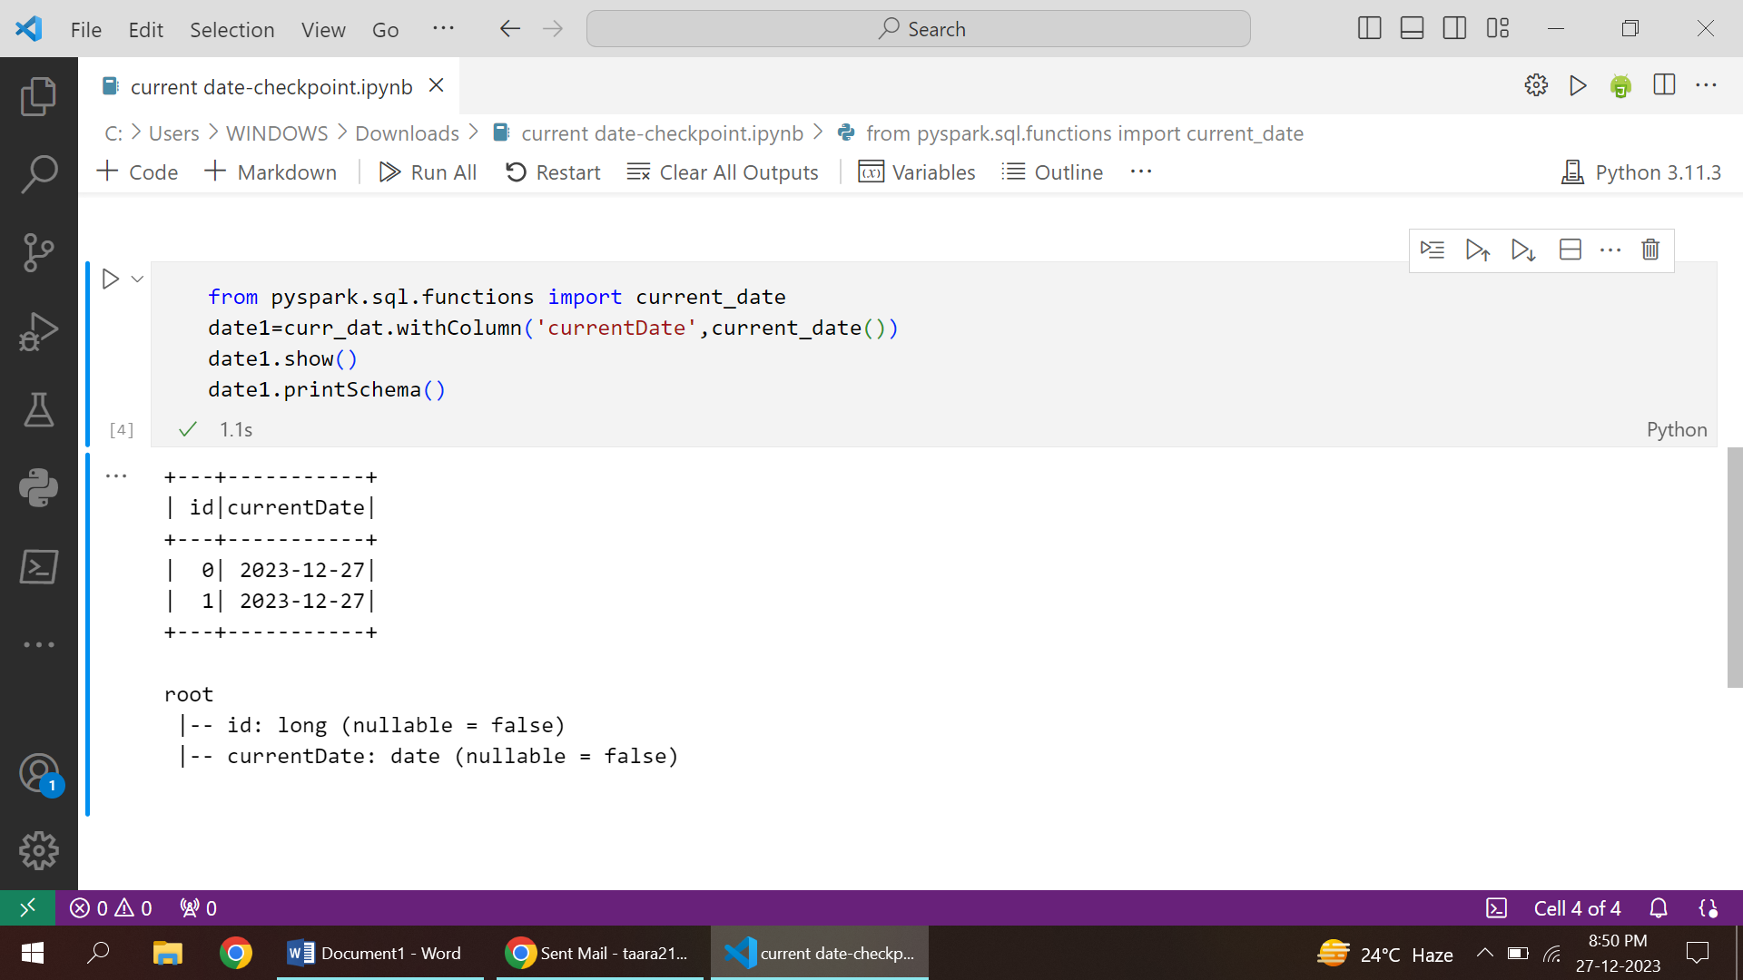

* The current_date() function in Spark SQL creates a DataFrame containing the current date and displays the result using the show() function.
* current_date() does not take any arguments and returns the current date as a column in Spark DataFrame.

2.PERCANTAGE FINDING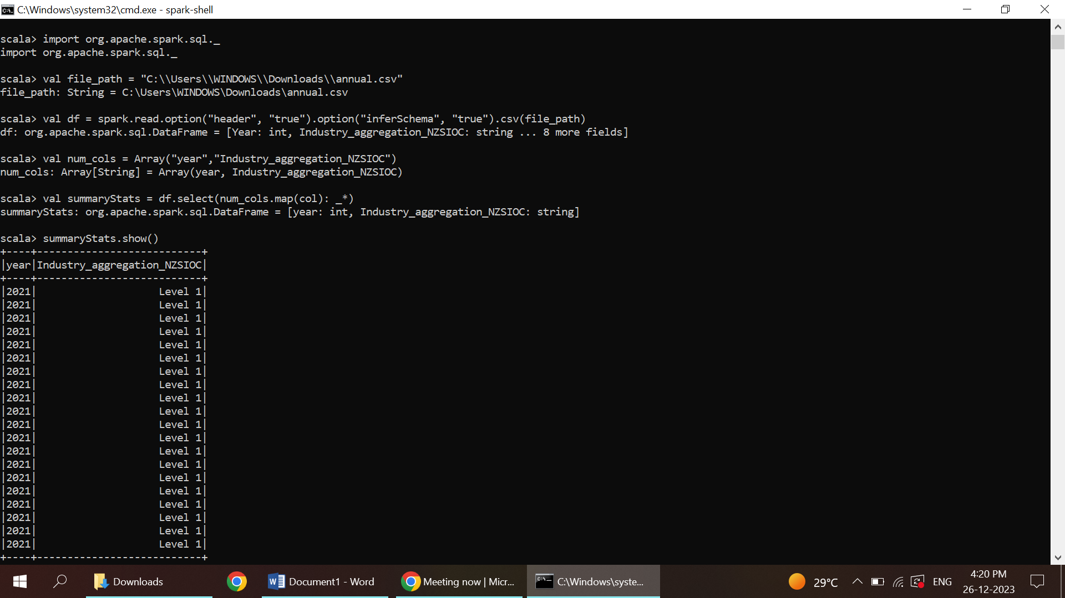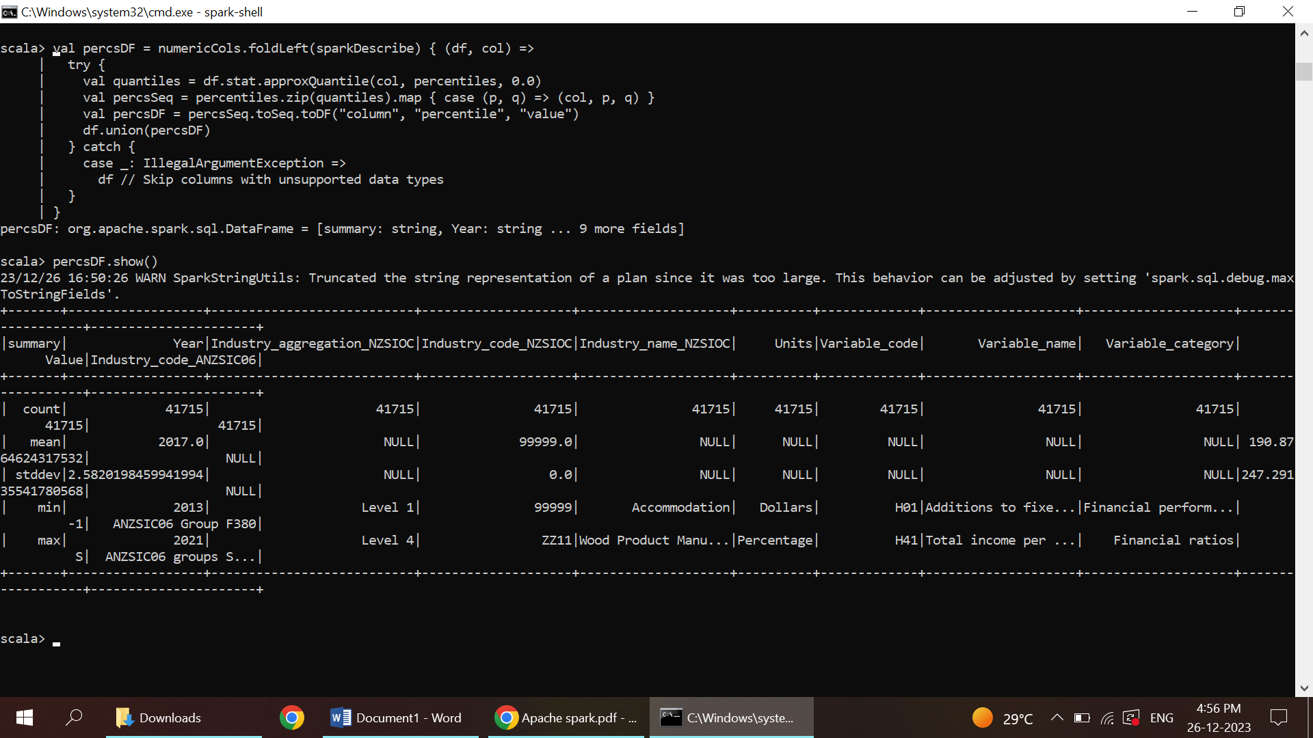

* create a sample DataFrame df containing value and total columns.
* Using the withColumn() function, we create a new column percentage by calculating the percentage, which is (value / total) * 100.
* Finally, we display the resulting DataFrame using resultDF.show().